

**BAHRIA UNIVERSITY, (Karachi Campus)**

*Department of Software Engineering*

PROPOSAL

**Course Title:**   **Course Code**:

**Course Instructor: Class**: BSE- (B)

**Lab Instructor:** Asma Shaheen  **Name: CCN**

PROJECT TITLE:

**HOTEL MANAGEMENT SYSTEM**

GROUP MEMBERS LIST:

**AIMAN ZIA SATTI 02-131212-028**

**KANWAL SHEHZADI 02-131212-027**

Submission Date**: 01/DEC/2023**

**PROJECT PROPOSAL**

1. **Introduction**

The Hotel Management System (HMS) project aims to develop an innovative solution for efficient and seamless management of hotel operations. Leveraging the capabilities of Cisco Packet Tracer, this project will create a simulation environment that replicates real-world hotel scenarios, allowing for the testing and optimization of key functionalities.

1. **Project Scope**

The hospitality industry faces unique challenges in managing diverse aspects of hotel operations. The Hotel Management System in Cisco Packet Tracer aims to address these challenges by providing a comprehensive and simulated environment for testing, refining, and implementing solutions to enhance the overall efficiency of hotel management.

1. **Project Abstract**

The Hotel Management System will cover the following key areas:

* **Reservation Management:** Streamlining the process of guest reservations and room allocation.
* **Check-In and Check-Out Procedures:** Optimizing the check-in and check-out processes for a smoother guest experience.
* **Inventory and Housekeeping Management:** Managing hotel inventory, tracking room status, and coordinating housekeeping activities.
* **Billing and Invoicing:** Automating billing processes and generating invoices for guests.
* **Guest Services:** Enhancing guest services through effective communication and feedback mechanisms.

1. **Functionalities**

This project has three floors,in the first floor there are three departments,Reception,Logistics, and Store.In the second floor there are three departments Finance,HR,Sales Marketing,while the third floor hosts IT and Admin.Therefore,the following are considered as part of the design and implementation.

* There should be three routers connecting each floor.
* All routers should be connected to each other using serial DCE cable
* The network between the routers should be 10.10.10.0/30,10.10.10.4/30,10.10.10.8/30
* Each floor is expected to have 1 switch
* Each floor is expected to have wifi networks connected to laptops and phones.
* Each department is expected to have a printer.
* Each department is expected to be in different vlan.

1. **Modules**

**KANWAL SHEHZADI:**

1. **Guest Wi-Fi Module:**

* Design and implement a secure Wi-Fi network for guests.
* Ensure proper authentication and access controls.
* Manage bandwidth allocation for guest internet access.

1. **VoIP and Intercom Module:**

* Integrate Voice over Internet Protocol (VoIP) for internal staff communication.
* Implement an intercom system for communication between different departments.
* Ensure seamless and secure communication channels.

1. **Network Security Module:**

* Implement security measures such as firewalls and intrusion detection/prevention systems.
* Regularly update and patch network devices to address security vulnerabilities.
* Monitor and manage the overall network security.

**AIMAN ZIA SATTI:**

1. **Room Connectivity Module:**

* Establish connectivity for each room, modeling smart devices and room control systems.
* Ensure secure and isolated VLANs for each room's network.
* Integrate room control systems into the network.

1. **Server and Data Management Module:**

* Set up a centralized server for storing guest information, reservations, and critical data.
* Implement backup and recovery procedures for data protection.
* Manage the overall server and data architecture.

1. **CCTV Integration Module:**

* Integrate CCTV cameras into the network for surveillance purposes.
* Implement secure access controls for monitoring and managing CCTV feeds.
* Ensure the seamless integration of CCTV systems with the overall network.

**6. Flow Diagram**

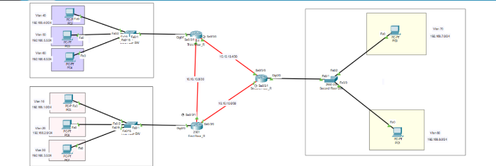

**7. References**

The development of this project will be guided by a thorough review of existing literature and technologies. Key references include:

* Smith, J. (2021). "Smart Homes: A Comprehensive Review of Technologies and Applications." Journal of IoT Research, 7(2), 112-135.
* Patel, R., & Wang, L. (2019). "IoT-Based Home Automation for Energy Management: A Review." IEEE Access, 7, 162248-162262.
* Johnson, M., et al. (2020). "Security in IoT-Based Smart Homes: A Comprehensive Survey." Journal of Cybersecurity, 5(1), 1-25. 1.

**Teacher Signature**: ______________________________________________

**Remarks**: ______________________________________________

**Submission Date**: ______________________________________________